

Subject: ERP Finance System Development Plan

By: Ahmad Almuhidat

**What is ERP Finance?**

Generally, an ERP financial module is a software program that gathers financial data and then generates reports. It allows you to communicate financial information more clearly to external partners such as vendors and your customers when needed. You can accomplish this through functions such as accounts payable, accounts receivable, general ledger, budgeting, and more.

**What is Accounting Software?**

It’s easy to confuse accounting and ERP financial software, but they have distinct characteristics. In essence, finance ERP focuses on the future with tools that emphasize budgeting, forecasting, and planning. Oppositely, accounting zeros in on current and historical data like general ledger balancing, reporting, expense management, tax management, etc. You may also find these features in finance modules to streamline the bookkeeping process.

Read on to learn about some of the most basic and popular aspects of ERP financial management software that you might consider in your ERP solution.

**Software Features**

**Profit Tracking**

A primary function of ERP financial management modules is profit tracking. The profit tracker will help provide a bird’s-eye view of the business’s overall financial health and financial resource leveraging. Tracking your profits will show you where more profits are coming from and determine the return on investment for any buy.

The tracker uses the incurred costs and receivables to calculate how much your organization profits from your efforts. Some programs will forecast future profits based on historical expenses and sales data.

**Ledger Management**

Ledger management is another fundamental function of ERP financial systems. A general ledger provides a thorough record of all financial transactions. It integrates with all of your other ERP modules, such as inventory management or customer relationship management.

Entries are typically made directly into the general ledger (GL), but your system may allow you to make entries anywhere within the application. Either way, you’ll be able to view your entries in one central location. You can keep track of a variety of things; for example, assets, liabilities, capital accounts, income, and expenses.

**Accounts Payable**

Accounts payable will manage all of the funds your company owes to your vendors and other creditors. An accounts payable feature integrates your expense data with your purchasing system so you can take control of your cash flows.

Automating accounts payable will save you money and time on labor hours as well as avoid human errors. The system can quickly process large amounts of invoices and other financial transactions between your company and vendors. Some applications offer document capture, also known as imaging features, which converts paper invoices into electronic documents.

**Accounts Receivable**

Accounts receivable allows your business to manage all of the funds customers owe them. It will track customer payments as well as manage invoices and cash.

Some ERP financial systems offer a portal for your customers where they can make payments or access invoices. You can automate tasks such as sending payment reminders or account statements and generating recurring invoices.

**Fixed Asset Management**

This solution tracks and manages all of your company’s tangible assets, such as manufacturing equipment, computers, company cars, and office space. It will take into account depreciation calculations, compliance requirements, and tax implications.

Asset management gives your organization better visibility in terms of utilization, costs, and maintenance. For example, keeping track of the depreciation of your assets can help you forecast expenditures and create budgets.

**Risk Management**

A great deal of business is ultimately about risk, and business leaders want to know that their organization is protected. Risk management tools can predict, analyze and manage crises.

These situations can range anywhere from financial issues to even natural disasters. Other potential calamities to manage with risk management solutions could be related to security, legal liabilities, compliance, or reputational risks.

**Reporting**

Analytics provide real-time access to financial data, which is crucial for maintaining your finances. The visibility helps you make data-driven predictions and decisions concerning your company’s finances.

On a basic level, reporting and analytics will show you where you’re generating revenue. But the dashboard can do so much more, such as display your sales, expected sales, expenses, and many other financial components. Typically, the dashboard is customizable, so you can choose which categories you would like to see. Review real-time data in graph formats so you may quickly understand your organization’s financial health.

**Multi-Currency Management**

If you have global clients, the ability to manage multiple currencies is critical. Multi-currency management automates the process of both buying and selling in foreign currencies. Currency conversion capabilities allow you to complete transactions in numerous currencies.

**Tax Management**

Tax management solutions store system taxation settings and provide tax audit and tax reporting functions. Leverage these settings across the system to provide a consistent collection of sales and VAT taxes.

Perhaps your tax management feature will complete the tedious task of determining sales tax jurisdictions of ship-to addresses or use prebuilt tax intelligence to process sales transactions in compliance with proper regulations. The capabilities of this accessory depend on which ERP financial system you purchase and the needs of your company. Either way, employing tax management within your organization is a great way to avoid spending time on mundane tasks.

**How the System Will Benefit the Business?**

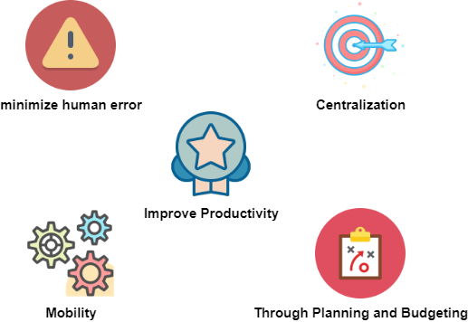

* **Improves Productivity**: Productivity will immediately increase once you automate mundane and time-wasting tasks.
* **Complete Financial Transparency**: The analytics dashboard and GL will provide authorized users with everything they need to know about your organization’s financials.
* **Thorough Planning and Budgeting**: The analytics and reporting function will allow you to forecast costs and potential revenue, then design your budgets accordingly.
* **Real-Time Financial Monitoring**: From a strange transaction to a spike in sales, you’ll always know what is going on within your financial sector at that exact moment.
* **Minimizes Human Error**: Accounting mistakes such as data entry errors are common but can be detected and avoided with the help of ERP financial software.
* **Organizes and Tracks Invoices and Documents**: The digital format prevents misplacing or losing documents, and they will automatically be filled into the proper place.
* **Mobility**: If you select a cloud-based financial ERP system, you’ll be able to access your financial tool anywhere, anytime.
* **No Missed Payments**: Accounts payable will notify you of upcoming payments, or you could choose to have them taken out automatically.
* **Integration**: Financial ERP modules integrate with other business systems, such as CRM, which will provide sales numbers and marketing budgets.
* **General ledger**: The GL is a comprehensive record of all of a company's financial transactions. It tracks such things as income and expenses, capital accounts, assets, and liabilities.
* **Centralization**: The General ledger (GL) is the central hub; you can access all of your company’s financial information in one place.

**Implementation**

**System Architecture**

The system will be divided into three layers, **interface**, **business logic**, and **database**, all three layers will be integrated with each other besides updating other related modules through a shared database.

The main goal of the development phase is to unify the technologies between the presentation layer and the business logic layer for better integration………………

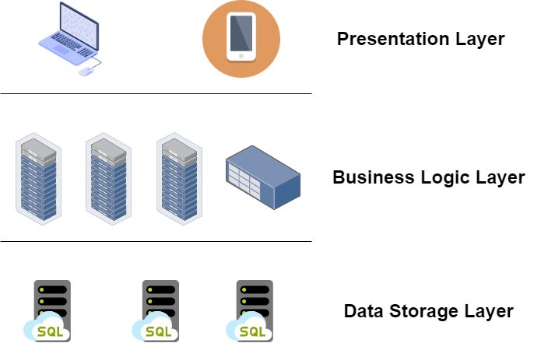

**UX/UI Design**

The wireframe will be designed using the draw.io service, then the design will be implemented using **React js** technology, React js was elected for several important features like:

* It’s a component-based framework, which gives us the ability to write less and more efficient code.
* It has great built-in functions similar to Ajax, Routes which save us time and effort so we can focus more on server-side functionality.
* very wide community support which gonna help to pass any technical issues, also it has a huge amount of external libraries that will make the work even easier and faster.
* It’s simple and easy to learn.

For info about **React js** functionality use this reference:

<https://codetoart.com/blog/why-reactjs-reason-to-choose-for-your-next-project>

**Business Logic**

In order to unify technologies used in the presentation layer and business logic, we will rely on **Node js** to implement business logic, **Node js** is easily employed as a server-side proxy where it can handle a large number of simultaneous connections in a non-blocking manner. It's especially useful for proxying different services with different response times or collecting data from multiple source points.

For info about **Node js** functionality use this reference:

<https://www.toptal.com/nodejs/why-the-hell-would-i-use-node-js#:~:text=PROXY-,Node.,data%20from%20multiple%20source%20points>.

**Data Storage**

The database system which will connect all the modules will be implemented using **MySQL**, it is the world's most popular open-source database that it provides comprehensive support for every application development need.

For info about **MySQL** functionality use this reference:

<http://www.databasequest.com/index.php/product-service/mysql-dbquest#:~:text=One%20of%20the%20reasons%20MySQL,%2Dstandard%20SQL%2C%20and%20more>.

**Hosting**

The system will be hosted on the Azure cloud service, and through the development phase, the system will be hosted on the Azure cloud service for **testing** purposes.

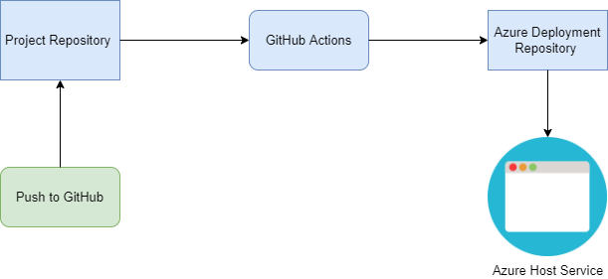

**Required functionality**

**Facilitating Payments**

The transfer of goods and services can take place smoothly only if there is a mechanism in place to ensure that the payments reach in time. This function is carried out by the payments system. The payment system can be viewed as a subset of the financial system. It is composed of several institutions, such as banks, depository institutions, and private companies.

**Transfer of Resources**

The cash flow that individuals and companies have sometimes may not match the cash flow that they desire. For instance, a retired person may have a lump sum of money. However, they may be more interested in a periodic sum of money. On the other hand, a company may want a significant sum of money upfront so that they can invest it in a project. In return, they may be willing to make a series of payments. Both of these tasks are accomplished through the financial system. The financial system allows investors to transform their resources and access them at a point of time that is convenient for them.

**Risk Management**

The derivatives market and the insurance market are an important part of the financial system. These markets have been created with the sole purpose of rationalizing the risk, which is an inevitable part of the life of individuals as well as businesses.

Using the financial system, businesses are able to pool their resources and cover themselves in case any unforeseen event happens. This can also be seen as a system of insurance.

**Managing Information**

The financial system provides important information, which is important for the well-being of the economy as a whole. One of the most important pieces of information provided by the markets is prices. The price information is the basis on which all of the economic theory has been developed. It is the basis on which all economic decisions are made.

**Efficient Middleman**

The financial system plays the role of an efficient middleman. This is because the financial system allows the savings to be diverted towards productive activities with the least amount of transaction costs. The financial system consists of various systems that have been created, keeping in mind the needs of the specific markets. For instance, banks and debt holders-based system has been created to fund infrastructure projects which continue over the long term. At the same time, equity-based securities have been created for investors who want to participate directly in the business by taking the associated risks.

**Pooling of Resources**

The financial system makes it possible for a group of investors to achieve what they could not have done individually. For instance, individual investors are limited by their knowledge when they start investing in stocks. However, when a group of investors gets together, the pool of funds becomes so large that they can afford to hire a team of specialists. This enables them to compete with the bigger funds on an equal footing. The ability to pool resources and deploy them safely is the hallmark of any financial system. All major financial systems and services like banking, insurance, and even mutual funds are the result of the proper discharge of this function.

**Conclusion**

Without a financial module, an ERP system wouldn’t work correctly. The features outlined in this article are the standard and popular ones; you can always add more advanced capabilities if you prefer. Remember that the key to finding the right financial ERP system is determining what your organization needs and aligning them with the features of your software system.

**References**

* <https://www.techtarget.com/searcherp/definition/ERP-finance-module>
* <https://www.toptal.com/nodejs/why-the-hell-would-i-use-node-js#:~:text=PROXY-,Node.,data%20from%20multiple%20source%20points>.
* <https://codetoart.com/blog/why-reactjs-reason-to-choose-for-your-next-project>
* <https://www.freeprojectz.com/uml-diagram/finance-management-system-uml-diagram>
* <https://freebalance.com/en/blog/government-technology/how-to-design-a-financial-management-information-system/>
* <http://xn--https-ix3b/www.selecthub.com/enterprise-resource-planning/erp-financial-management-functions/#:~:text=Zoho%20Books-,What%20is%20ERP%20Finance%3F,and%20your%20customers%20when%20needed>
* <http://www.databasequest.com/index.php/product-service/mysql-dbquest#:~:text=One%20of%20the%20reasons%20MySQL,%2Dstandard%20SQL%2C%20and%20more>.
* <http://www.sieroassociates.co.ke/financial-systems-designs-and-implementation>
* <https://www.visualsouth.com/blog/erp-implementation-project-plan#ERP-Implementation-III>
* <https://nix-united.com/blog/enterprise-software-solution-how-to-implement-it-properly/>
* <https://www.managementstudyguide.com/functions-of-a-financial-system.htm>
* <https://www.visualsouth.com/blog/erp-customization>
* <https://www.visualsouth.com/blog/erp-implementation-failures>
* <https://www.managementstudyguide.com/functions-of-a-financial-system.htm>